**Township of Medford**



**POTABLE WATER TESTING - 2025**

**Bid Package**

**49 Union Street, Medford, NJ 08055**

Bids Due: Jan 30, 2025before **10:00 AM**

This Bid Submitted By: _________________________________________________

**TABLE OF CONTENTS**

1. ADVERTISEMENT FOR BID
2. INSTRUCTIONS TO BIDDERS &

GENERAL SPECIFICATIONS

1. DETAILED SPECIFICATIONS*
2. FORM OF PROPOSAL*
3. OWNERSHIP DISCLOSURE STATEMENT*
4. NON-COLLUSION AFFIDAVIT*
5. AFFIRMATIVE ACTION REQUIREMENT &

AMERICANS WITH DISABILITES ACT

1. BUSINESS REGISTRATION CERTIFICATE
2. STATE REQUIRED DISCLOSURES*
3. CHECKLIST FOR BID SUBMITTAL*

*Items marked with an asterisk need to be submitted with bid

**I**

**TOWNSHIP OF MEDFORD**

**ADVERTISEMENT FOR BIDS FOR**

**POTABLE WATER TESTING - 2025**

Notice is hereby given that sealed bids will be received by the Township Clerk of the Township of Medford, New Jersey for the supply of POTABLE WATER TESTING (laboratory services) to be delivered to the Township’s Clerk’s Office, 49 Union Street, Medford, NJ, on or before 10:00 A.M. prevailing time on January 30, 2025, and publicly opened and read aloud in the office of the Township Clerk of the Township of Medford at 49 Union Street, Medford, New Jersey. Specifications and contract documents may be obtained from the Township of Medford, Office of the Township Clerk, 49 Union Street, Medford, New Jersey between 8:30 A.M. and 4:30 P.M., Monday-Friday or on the Township website at www.medfordtownship.com. Submissions must be on the standard proposal form in the manner designated therein and enclosed in a sealed envelope bearing the name and address of the bidder and the contract description on the outside, addressed to the Municipal Clerk of the Township of Medford. Bidders are to comply with the requirements of P.L. 1975, C. 127. (N.J.A.C. 17:27).

All bids shall be submitted only at the hours, date and place indicated above for receiving sealed bids. The Township will reject submissions for this Contract where vendors are not properly qualified in accordance with the requirements of the specifications. The right is also reserved to reject any or all proposals or to waive any informalities where such informality is not detrimental to the best interest of the Township of Medford.

_______________________________

Tara Wicker, RMC

Township Clerk

**II**

**TOWNSHIP OF MEDFORD**

**POTABLE WATER TESTING - 2025**

**INSTRUCTIONS TO BIDDERS AND GENERAL SPECIFICATIONS**

**INSTRUCTIONS TO BIDDERS AND STATUTORY REQUIREMENTS**

**1. SUBMISSION OF BIDS**

A. The Township of Medford, Burlington County, New Jersey (hereinafter referred to as “Township”) invites sealed bids pursuant to the Notice of Bidders.

B. Sealed bids will be received by the designated representative at 10:00 A.M. prevailing time on January 30, 2025 at which time said bids will be publicly opened and read aloud.

C. The bid proposal form shall be submitted, in a sealed envelope: (1) addressed to the Township, (2) bearing the name and address of the bidder written on the face of the envelope, and (3) clearly marked “POTABLE WATER TESTING - 2025”.

D. It is the bidder’s responsibility to see that bids are presented to the Township on or prior to the hour designated and at the place designated. Bids may be hand delivered or mailed; however, the Township disclaims any responsibility for bids forwarded by regular or overnight mail. If the bid is sent by overnight mail, the designation in section C, above, must also appear on the outside of the delivery company envelope. Bids received after the designated time and date will be returned unopened.

E. Sealed bids forwarded to the Township before the time of opening of bids may be withdrawn upon written application of the bidder who shall be required to produce evidence showing that the individual is or represents the principal or principals involved in the bid. Once bids have been opened, they must remain firm for a period of sixty (60) calendar days.

F. All prices and amounts must be written in ink or preferable typewritten. Bids containing any conditions, omissions, unexplained erasures or alterations, items not called for in the bid proposal form, attachment of additive information not required by the specifications, or irregularities of any kind, may be rejected by the Township. Any changes, white-outs, strike-outs, etc. on the proposal page must be initialed in ink by the person responsible for signing the bid.

G. Each bid proposal form must give the full business address of the bidder and be signed by an authorized representative. Bids by partnerships must furnish the full name of all partners and must be signed in the partnership name by one of the members of the partnership or by an authorized representative, followed by the signature and designation of the person signing. Bids by corporations must be signed in the legal name of the corporation, followed by the name of the State in which incorporated and must contain the signature and designation of the president, secretary or other person authorized to bind the corporation in the matter. When requested, satisfactory evidence of the authority of the officer signing shall be furnished.

H. Bidders must insert prices for furnishing all of the materials and/or services required by these specifications. Prices shall be net.

I. The contractor shall guarantee any or all materials and services supplied under these specifications. Defective or inferior items shall be replaced at the expense of the vendor. In case of rejected materials, the vendor will be responsible for return freight charges.

J. Bidder should be aware of the following statutes that represent “Truth in Contracting” laws:

K. NJSA 2C:21-34, et seq. governs false claims and representations by bidders

L. NJSA 2C:27-10 provides that a person commits a crime if said person offers a benefit to a public servant.

M. NJSA 2C:27-11 provides that a bidder commits a crime if said person, directly or indirectly, confers or agrees to confer any benefit not allowed by law to a public servant.

N. All forms shall be completed and attached to the bid proposal. Bidder is altered to the Proposal Checklist page. Failure to sign and give all information in the bid may result in the bid being rejected.

O. The person designated as the Township’s Representative is Ronnie Fowler, Public Works & Utilities Director or his designated agent. The Township’s Representative will present the final recommendation for award of the bid to the Township.

P. The Township is seeing bids for a one year period, commencing on February 1, 2025, with the option of a one year extension. Contract extension shall largely be based upon whether the Township’s permit conditions/ requirements for potable water testing remain static.

**2. BID SECURITY**

The following provisions if indicated by an (X), shall be applicable to this bid and be made part of the bidding documents:

A. BID GUARANTEE ( )

Bidder shall submit with the bid a certified check, cashier’s check or bid bond in the amount of ten percent (10%) of the total price bid, but not in excess of $20,000, payable unconditionally to the Township. When submitting a Bid Bond, it shall contain Power of Attorney for full amount of Bid Bond from a surety company authorized to do business in the State of New Jersey and acceptable to the Township. The check or bond of the unsuccessful bidder(s) shall be returned to all but the three (3) lowest bidders with ten (10) days after opening of the bids, Sunday and Holidays excepted. The check or bond of the three (3) lowest bidders shall be returned with three (3) days, Sundays and Holidays excluded, of the award and signing of the contract and approval of the required performance bond or other security is submitted. The check or bond of the successful bidder shall be forfeited if the bidder fails to enter into a contract pursuant to N.J.S.A. 40A:11-21. Failure to submit a bid guarantee shall result in rejection of the bid.

B. CONSENT OF SURETY ( )

Bidder shall submit with the bid a Certificate (Consent of Surety) with Power of Attorney for full amount of bid price from a Surety Company authorized to do business in the State of New Jersey and acceptable to the Township stating that it will provide said bidder with a Performance Bond in the full amount of the bid. This certificate shall be obtained in order to confirm that the bidder to whom the contract is awarded will furnish Performance Bonds from an acceptable surety company on behalf of said bidder, any or all subcontractors or be each respective subcontractor or by any combination thereof which results in performance security equal to the total amount of the contract, pursuant to N.J.S.A. 40A:11-22. Failure to submit consent of surety form shall result in rejection of the bid.

C. PERFORMANCE BOND ( )

Successful bidder shall simultaneously with the delivery of the executed contract, submit an executed bond in the amount of the one hundred percent (100%) of the acceptable bid as security for the faithful performance of this contract and to guarantee payment of laborers and supplies for the labor and material used in the work performed under the contract.

The performance bond provided shall not be released until final acceptance of the whole service and/or materials and then only if any liens or claims have been satisfied.

Failure to submit this with the executed contract shall be cause for declaring the contract null and void pursuant to NJSA 40A:11-22

D. SURETY DISCLOSURE STATEMENT AND CERTIFICATION ( )

The surety shall have the minimum surplus and capital stock on net cash assets required by N.J.S.A. 17:17-6 or 17:17-7 whichever is appropriate at the time the invitation bid is issued.

The Bid Bond shall have attached thereto a Surety Disclosure Statement and Certification to which each surety executing the bond shall have subscribed.

The surety on such bond or bonds shall be a duly authorized surety company authorized to do business in the State of New Jersey. N.J.S.A. 17:31-5.

**3. INTERPRETATION AND ADDENDA**

A. The bidder understands and agrees that its bid is submitted on the basis of the specifications. The bidder accepts the obligation to become familiar with these specifications.

B. Bidders are expected to examine the specifications and related documents with care and observe all their requirements. Ambiguities, errors or omissions noted by bidders should be promptly reported in writing to the Township’s designated representative. In the event the bidder fails to notify the Township of such ambiguities, errors or omissions, the bidder shall be bound by the bid.

C. No oral interpretation of the meaning of the specifications will be made to any bidder. Every request for an interpretation shall be in writing, addressed to the Township’s representative stipulated in the bid. In order to be given consideration, written requests for interpretation must be received at least seven (7) days prior to the date fixed for the opening of the bids. Any and all such interpretations and any supplemental instructions will be in the form of written addenda to the specifications, and will be distributed to all prospective bidders, in accordance with N.J.S.A. 40A:11-23. All addenda so issued shall become part of the contract documents, and shall be acknowledged by the bidder in the bid. The Township’s interpretations or corrections thereof shall be final.

D. Discrepancies in Bids

1. If the amount shown in words and its equivalent in figures do not agree, the written words shall be binding. Ditto marks are not considered writing or printing and shall not be used.

2. In the event that there is a discrepancy between the unit prices and the extended totals, the unit prices shall prevail. In the event there is an error of the summation of the extended totals, the computation by the Township of the extended totals shall govern.

E. Bid Conference

If stated in the Notice to Bidders:

_X_ A pre-bid conference is not required for this bid.

___ A pre-bid conference for this proposal will be held on __________________.

Attendance is not mandatory, but is strongly recommended. Failure to attend does not relieve the bidder of any obligations or requirements.

**4. BRAND NAMES, PATENTS AND STANDARDS OF QUALITY**

A. Brand names and/or descriptions used in this bid are to acquaint bidders with the type of commodity desired and will be used as a standard by which alternate or competitive materials offered will be judged. Brand names are to be treated as the brand name “or equal” as required by the Local Public Contracts Law, N.J.S.A. 40A:11-1, et seq. Competitive items must be equal to the standard described and be of the same quality of work.

B.It is the responsibility of the bidder to demonstrate the equivalency of item(s) offered. The Township reserves the right to evaluate the equivalency of an item(s) which, in its deliberations, meets or does not meet its requirements.

C. In submitting its bid, the bidder certifies that the merchandise to be furnished will not infringe upon any valid patent or trademark and that the successful bidder shall, at its own expense, defend any and all actions or suits charging such infringement, and will save the Township harmless from any damages resulting from such infringement.

D. Only manufactured and farm products of the United States, wherever available, shall be used on this contract pursuant to N.J.S.A. 40A:11-18.

E. The successful bidder shall guarantee any or all goods, services and commodities supplied under these specifications. Defective or inferior goods shall be replaced at the bidder’s sole expense. The contractor will be responsible for return freight, delivery or restocking charges.

**5. INSURANCE AND IDEMNIFICATION**

A. Insurance Requirements

The insurance documents indicated by an (X) shall include but are not limited to the following coverages.

_X_ I. General Liability:

A. Commercial General Liability with a $1,000,000 and $2,000,000 Aggregate per occurrence for Bodily Injury, Personal and Advertising Injury and Property Damage including Blanket Contractual Liability, Products Liability.

B. Contractor’s insurance to be primary and non-contributory.

C. 30-day notice of intent to cancel, non-renew, or make material change in coverage.

D. Municipality to be named as “Additional Insured.”

_X_ II. Automobile Liability:

A. $1,000,000 Combined Single Limit of Liability for Bodily Injury and Property Damage per accident.

B. Coverage to include “Owned, Non-Owned, and Hired” automobiles.

C. 30-day notice of intent to cancel, non-renew, or make material change in coverage.

_X_ III. Workers’ Compensation/Employer’s Liability:

A. Certificate of Insurance indicating “statutory” limits.

B. 30-day notice of intent to cancel, non-renew or make material changes in coverage.

C. Employer’s Liability, $1,000,000.

__ IV. Cyber Security and Privacy Liability Insurance.

A. $1,000,000 per occurrence or claim

B. 30-day notice of intent to cancel, non-renew or make material change in coverage

C. Said policies shall contain the following coverage:

1. Liability arising from the theft, dissemination and/or use of confidential or proprietary information, including but not limited to, personally identifiable information (PII), protected health information (PHI), security codes, access codes, passwords, security codes or personal identification numbers (PINS), if applicable;

2. Notification costs, credit monitoring and other expert services, regulatory fines and defense costs for claims or suits in relation to Par. C.1. above;

3. Network security liability arising from unauthorized access to, use of, or tampering with computer systems, including hacker attacks;

4. Liability arising from the introduction of a computer virus into, or otherwise causing damage to the vendor’s (first party) or Township’s computers, computer system, communications system or network, or similarly related property and the data, software and programs thereon;

5. Liability arising from professional misconduct or lack of the requisite skill required for the performances of services defined in the contract or agreement.

D. Municipality to be named as “Additional Insured.”

_X__ V. Other Forms of Insurance Required: Watercraft coverage consistent with 5.A.II. Automobile Liability if

utilizing water craft to perform some or all services.

B. Certificates of Required Insurance

The contractor shall, at its own expense, take out all necessary insurance coverage required and shall submit to the Township evidence that Comprehensive General Liability, and where applicable, necessary Worker’s Compensation Employer’s Liability Insurance in the amounts specified. Coverage shall be with the acceptable insurance companies operating on admitted basis in the State of New Jersey and shall name the Township as an additional insured. Satisfactory proof of insurance shall consist of a certificate of each insurer, insuring the contractor under the contract.

The certificate shall contain the following information (except in the case of Worker’s Compensation Insurance, items 1, 2 and 4 will be sufficient).

1. Name and address of insured.

2. Number of the policy or types of insurance enforced thereunder on the date born by such certificate.

3. The expiration date of the policy and the limit or limits of liability thereunder on the date born by such certificate.

4. A statement that the insurance of the type afforded by the policy, applies to all. The operations of the project which were undertaken by the insured during the performance of the contract including collision coverage for vehicles in tow.

5. Statement that the insurance company will not cancel the policy except upon thirty (30) days notice to the Township.

C. Indemnification

Proposer agrees that it shall indemnify, save harmless and defend the Township of Medford, its elected and appointed officials, its employees, agents, volunteers and others working on behalf of the Township, from and against any and all claims, losses, costs, attorney’s fees, damages, or injury including death and/or property loss, expense claims or demands arising out of or caused or alleged to have been caused in any manner by a defect in any equipment, materials or services supplied under the Proposal/ Agreement or by the performance of any work under the Proposal/ Agreement, including all suits or actions of every kind or description brought against the Township, either individually or jointly with the Proposer for or on account of any damage or injury to any person or persons or property, caused or occasioned or alleged to have been caused by, or on account of, the performance of any work pursuant to or in connection with the Proposal/ Agreement, or through any negligence or alleged negligence in safeguarding the work area, or through any act, omission or fault or alleged act, omission or fault or alleged act, omission or fault of the Proposer, its employees, subcontractors/ sub-consultants or agents.

**6. PREPARATION OF BIDS**

A. The Township is exempt from any local, state or federal sales, use or excise tax.

B. Successful bidder shall be responsible for obtaining any applicable permits or licenses from any government entity that has jurisdiction to require the same. All bids submitted shall include this cost in the bid price proposal.

**7. STATUTORY AND OTHER REQUIREMENTS**

A. Mandatory Affirmative Action Certification

No firm may be issued a contract unless it complies with the affirmative action regulations of N.J.S.A. 10:5-3 1 et seq. (P.L. 1975, c. 127).

1. Procurement, Professional and Service Contracts

All successful vendors must submit, within seven (7) days after the receipt of the notice of intent to award the contract or the receipt of the contract, one of the following:

i. A photocopy of a valid letter for an approved Federal Affirmative Action Plan (good for one year from the date of the letter), or

ii. A photocopy of an approved Certificate of Employee Information Report, or

iii. An initial Affirmative Action Employee Information Report (AA-302), such forms to be provided by Township.

B. Americans with Disabilities Act of 1990

Discrimination on the basis of disability in contracting for the purchase of bids and services is prohibited. The successful bidder is required to read Americans with Disabilities language that is part of this specification and agrees that the provisions of Title II of the Act are made a part of the contract. The successful bidder is obligated to comply with the Act and to hold the Township harmless.

C. Stockholder Disclosure

Chapter 33 of Public Laws of 1977 provides that no corporation or partnership shall be awarded any contract for the performance of any work or the furnishing of any materials or supplies, unless, prior to the receipt of the bid or accompanying the bid of said corporation or partnership, there is submitted a statement setting forth the names and addresses of all stockholders in the corporation or partnership who own ten percent or more of its stock of any class, or of all in individual partners in the partnership who own a ten percent or greater interest therein. The Stockholder Disclosure Form shall be completed and attached to the bid proposal.

D. The New Jersey Worker and Community Right to Know Act

The manufacturer or supplier of a substance or mixture shall supply the Chemical Abstracts Service number of all the components of the mixture or substance and the chemical name. The manufacturer and supplier must properly label each container. Further, all applicable Material Safety Data Sheets (MSDS) – hazardous substance fact sheet – must be furnished.

E. Non-Collusion Affidavit

The Non-Collusion Affidavit, which is part of these specifications, shall be properly executed and submitted with the bid proposal.

F. Non-Assignment of Contract

The bidder shall not assign, transfer, convey, sublet or otherwise dispose of the contract, or his rights, title or interest in or to the same of any part thereof except as otherwise provided herein. Any subletting of the Contract in no way relieves the Contractor from his full obligations under this Contract.

**8. METHODS OF AWARD**

A. The length of the contract, if applicable, shall be stated in the technical specifications. Pursuant to the requirements of N.J.A.C. 5:30-5.1 et seq., any contract resulting from this bid solicitation shall be subject to the availability and appropriation of sufficient funds annually.

B. If the award is to be made on the basis of a base bid only, it shall be made to that responsible bidder submitting the lowest base bid.

C. If the award is to be made on the basis of a combination of a base bid with selected options, it shall be made to that responsible bidder submitting the lowest net bid.

D. The owner may also elect to award the contract on the basis of unit prices.

E. The form of contract shall be submitted by the owner to the successful bidder. Terms of the specifications/bid package prevail. Bidder exceptions must be formally accepted by the owner.

F. The owner reserves the right to award equal or tie bids to any of the tied bidders.

**9. REJECTION OF BIDS**

A. Reservation of Rights

Township reserves the right to waive any informalities, irregularities or minor defects in the bids received and to report any and all bids. In addition, Township reserves the right to reject any and all bids for reasons that the Township deems appropriate, and where said rejections is, in the judgment of the Township, determined to be in the best interest of the municipality.

B. Availability of Funds

Pursuant to statutory requirements, any contract resulting from this bid shall be subject to the availability and appropriation of sufficient funds annually.

C. Multiple Bids Not Allowed

More than one bid from an individual, a firm or partnership, a corporation or association under the same or different names shall not be considered.

D. Unbalanced Bids

Bids which are obviously unbalanced may be rejected.

E. Unsatisfactory Past Performance

Bids received from bidders who have previously failed to complete contracts within the time scheduled therefore, or who have performed prior work for the Township in an unacceptable manner, may be rejected. Bidders may also be rejected for “prior negative experience” pursuant to N.J.S.A. 40A:11-4.

F. Failure to Enter Contract

Should the bidder, to whom the contract is awarded, fail to enter into a contract within 21 days, Sundays and Holidays excepted, the Township may then, at its option, accept the bid of the next lowest responsible bidder.

G. Statutory Reasons

The reasons set forth in N.J.S.A. 40A:11-13.2.

**10. TERMINATION OF CONTRACT**

A. If, through any cause, the successful bidder shall fail to fulfill in a timely and proper manner obligations under this contract or if the contractor shall violate any of the requirements of this contract, the Township shall thereupon have the right to terminate this contract by giving written notice to the contractor of such termination and specifying the effective date of termination. Such termination shall relieve the Township of any obligation for balances to the contractor of any sum or sums set forth in the contract.

B. Notwithstanding the above, the contractor shall not be relieved of liability to the Township for damages sustained by the Township by virtue of any breach of the contract by the contractor and the Township may withhold any payments to the contractor for the purpose of compensation until such time as the exact amount of the damage due the Township from the contractor is determined.

C. The contractor agrees to indemnify and hold the Township harmless from any liability to subcontractors/suppliers concerning payment for work performed or goods supplied arising out of the lawful termination of the contract by the Township under this provision.

D. In case of default by the successful bidder, the Township may procure the articles or services from other sources and hold the successful bidder responsible for any excess cost occasioned thereby.

E. Continuation of the terms of this contract beyond the fiscal year is contingent on availability of funds in the following year’s budget. In the event of unavailability of such funds, the Township reserves the right to cancel this contract.

**11. GOVERNING LAW**

This contract shall be governed by and construed in accordance with the Local Public Contracts Law of the State of New Jersey (N.J.S.A. 40A:11-1 et seq.)

**12. OTHER REQUIREMENTS**

A. **There are no exceptions to the specifications.** All work must be done in compliance with all local, state, and federal laws.

B. **Manufacturer’s Specifications**: Each bid shall be accompanied by a detailed set of *Manufacturer’s Specifications*, if applicable.

C. **Prices and Payments**: Unless otherwise specified, the cost of the bid shown shall be the cost to the Township for services provided within the geographical boundaries of the Township of Medford.

Total price on bidder’s proposal sheet must include all items listed in the specifications. Listing any items contained in the specification as an extra cost item, unless specifically requested to do so in the specifications, will automatically be cause for rejection.

Bidder will compute pricing less federal and state taxes. It is understood that any applicable taxes will be added to the proposed prices, unless the purchaser furnishes appropriate tax-exempt forms.

D. Pursuant to N.J.S.A. 40A:11-15, the parties’ contract may be extended for a one-year term after the expiration of the original contract period, contingent upon the approval of the governing body by resolution with the agreement of the Vendor. Contract extensions shall be subject to the availability and appropriation of funds for each year the contract is to be extended. All terms and conditions of the contract shall remain the same. Any price changes authorized on contract extensions shall be allowed pursuant to N.J.S.A. 40A:11-15.

**III**

**MEDFORD TOWNSHIP, NEW JERSEY**

**DETAILED SPECIFICATIONS**

**POTABLE WATER TESTING - 2025**

13. TECHNICAL SPECIFICATIONS:

The Township, on behalf of the Water Utility within the Department of Public Works & Utilities, is seeking qualified laboratories with New Jersey Department of Environmental Protection (NJDEP) laboratory certification in Potable (Drinking) Water to perform laboratory testing of potable water samples taken from Township owned or controlled water distribution systems to maintain compliance with various NJDEP permits.

Testing shall be performed in accordance with NJDEP Office of Quality Assurance standards, and shall utilize Department Sanctioned Analytical Methods (DSAMs) for the substances outlined in the attachments for the Township’s licensed water system.

Potable Water Testing:

By way of reference only, the locations listed in the attachment labeled “Monitoring Schedule for Medford Twp. Dept. of Muni (NJ0320001)” indicate the sources where samples are to be drawn by Township staff. The Monitoring Schedule for Medford Twp. Dept. of Muni (NJ0320001) indicates the substances and estimated quantities of water quality samples for calendar year 2025 which the Township is required to test by the NJDEP. Township staff shall be responsible for taking samples in containers supplied by the vendor and securing them in a locked refrigerator inside the Township’s Department of Public Works & Utilities administration building. The vendor shall take delivery (pick up) water samples every Tuesday between the hours of 10:00 AM – 2:00 PM at the DPM&U administration building, 18 Fostertown Road, Medford, NJ, 08055.

The estimated quantities listed in the attachment are not a guarantee of the number of samples that will be submitted for testing. Consequently, the successful bidder must provide a per sample price in case of the need for resampling or additional required sampling.

Township personnel will draw all water samples for each of the locations listed in the attachment. Upon acceptance of samples by the laboratory, the laboratory shall ensure uninterrupted chain of custody for the samples tested and results reported.

All pricing shall include the provision of sample containers, delivery of containers, analysis, and timely reporting of results electronically to the NJDEP via the E2 system, as well as providing a hard copy or .pdf record to the Township’s Department of Public Works/ Water Utility.

Turn around time for all work should be no later than ten (10) business days from the receipt of the samples by the laboratory. The exception being the Total Coliform Bacteria results, which must be available 24-48 hours after sampling. In the case of failed bacteria results or other water quality samples that need to be resampled, the Licensed Water Operator for the Medford Township Water Division should be notified within twenty-four (24) hours. The proposed vendor shall also report all laboratory test results to the NJDEP via the E2 system, unless otherwise indicated on the chain-of-custody form.

The vendor shall state any other fees that may be associated with potable water sampling (example: form preparation etc.).

**IV**

**TOWNSHIP OF MEDFORD**

**FORM OF PROPOSAL**

The bidder shall indicate per unit pricing on the Attachment labeled “Monitoring Schedule for Medford Twp. Dept. of Muni (NJ0320001).”

The undersigned, as bidder, declares that he/she has carefully examined the specifications and is familiar with the work to be bid and will supply the services requested for the prices specified to the Township of Medford, 49 Union Street, Medford, N.J. 08055.

This page shall accompany the attachment labeled “Monitoring Schedule for Medford Twp. Dept. of Muni (NJ0320001).”

**ITEM BID NAME: POTABLE WATER TESTING**

PROPOSAL BID DATE:

VENDOR NAME:

ADDRESS:

TELEPHONE NO. FAX NO.

CONTACT PERSON: TITLE

EMAIL:

|  |
| --- |
|  |

**V**

**TOWNSHIP OF MEDFORD**

**STOCKHOLDER DISCLOSURE CERTIFICATION**

**N.J.S.A. 52:25-24.2 (P.L. 1977 c33)**

Failure of the bidder/respondent to submit the required information is cause for automatic rejection.

Legal Name of Bidder: ___________________________________________________________

I certify that the list below contains the names and home address of all stockholders holding 10% or more of the issued and outstanding stock of the undersigned.

I certify that no one stockholder owns 10% or more of the issued and outstanding stock of the undersigned.

**Check the box that represents the type of business organization:**

Partnership Corporation Sole Proprietorship

Limited Partnership Limited Liability Corporation Limited Liability Partnership

Subchapter S Corporation

Complete if the bidder/respondent is one of the 3 types of Corporations:

Date Incorporated: ____________________ Where Incorporated: _______________________________

Business Street Address: __________________________________________________________________

City: ________________________________ State: _________________ Zip Code: ________________

Telephone #: ______________________________ Fax #: _____________________________________

Listed below are the names and addresses of all stockholders, partners or individuals who own ten percent (10%) or more of its stock of any class, or who owns ten percent (10%) or greater interest therein. Sign and notarize the form below, and if necessary, complete the stockholder list below.

**Stockholders:**

Name: __________________________________ Name: _____________________________________

Home Address: ___________________________ Home Address: _____________________________

_________________________________________ _____________________________________________

Name: __________________________________ Name: _____________________________________

Home Address: ___________________________ Home Address: _____________________________

_________________________________________ _____________________________________________

Subscribed and sworn before me this ______day of _________________, 20_____

Notary Public of: ________________________ _______________________________________

(Affiant Signature)

________________________________________ ____________________________________________

(Print Name & Title of Affiant)

My Commission Expires: ________________

(Seal)

**VI**

**TOWNSHIP OF MEDFORD**

**______________________________________**

**NON-COLLUSION AFFIDAVIT**

State of New Jersey

County of ______________________________ ss:

I, ______________________________________ residing in ____________________________________

(*name of affiant*) *(name of municipality)*

In the County of ________________________________ and State of _______________________ of full age, being duly sworn according to law on my oath depose and say that:

I am __________________________________________ of the firm of ________________________________

*(Title or position)* (*name of the firm)*

______________________________________________ the bidder making this Proposal for the bid entitled

_____________________________________________, and that I executed the said proposal with

(Title of bid proposal)

full authority to do so that said bidder has not, directly or indirectly entered into any agreement, participated in any collusion, or otherwise taken any action in restraint of free, competitive bidding in connection with the above named project; and that all statements contained in said proposal and in this affidavit are true and correct, and made with full knowledge that the Township of Medford relies upon the truth of the statements contained in said Proposal and in the statements contained in this affidavit in awarding the contract for the said project.

I further warrant that no person or selling agency has been employed or retained to solicit or secure such contract upon agreement or understanding for a commission, percentage, brokerage, or contingent fee, except bona fide employees or bona fide established commercial or selling agencies maintained by ______________________________________________.

Subscribed and sworn before me this ______day of _________________, 20_____

Notary Public of: ________________________ _______________________________________

(Affiant Signature)

________________________________________ ____________________________________________

(Print Name & Title of Affiant)

My Commission Expires: ________________

(Seal)

**VII**

**TOWNSHIP OF MEDFORD**

**MANDATORY STATE PROCUREMENT FORMS**

**EXIBIT A**

**N.J.S.A. 10:5-31 and N.J.A.C. 17:27**

**MANDATORY EQUAL EMPLOYMENT OPPORTUNITY LANGUAGE**

**Goods, Professional Services and General Service Contracts**

**(Mandatory Affirmative Action Language)**

During the performance of this contract, the contractor agrees as follows:

The contractor or subcontractor, where applicable, will not discriminate against any employee or applicant for employment because of age, race, creed, color, national origin, ancestry, marital status, affectional or sexual orientation or sex. Except with respect to affectional or sexual orientation, the contractor will take affirmative action to ensure that such applicants are recruited and employed, and that employees are treated during employment, without regard to their age, race, creed, color, national origin, ancestry, marital status, affectional or sexual orientation or sex. Such action shall include, but not be limited to the following: employment, upgrading, demotion, or transfer; recruitment or recruitment advertising; layoff or termination; rates of pay or other forms of compensation; and selection for training, including apprenticeship. The contractor agrees to post in conspicuous places, available to employees and applicants for employment, notices to be provided by the Public Agency Compliance Officer setting forth the provisions of this nondiscrimination clause. The contractor or subcontractor, where applicable will, in all solicitations or advertisements for employees placed by or on behalf of the contractor, state that all qualified applicants will receive consideration for employment without regard to age, race, creed, color, national origin, ancestry, marital status, affectional or sexual orientation or sex.

The contractor or subcontractor or subcontractor, where applicable, will send to each labor union or representative of workers with which it has a collective bargaining agreement or other contract understanding, a notice, to be provided by the agency contracting officer, advising the labor union or workers representative of the contractor’s commitments under this act and shall post copies of the notice in conspicuous places available to employees and applicants for employment.

The contractor or subcontractor, where applicable, agrees to comply with any regulations promulgated by the Treasurer pursuant to N.J.S.A. 10:5-31 et seq., as amended and supplemented from time to time and the Americans with Disabilities Act.

The contractor or subcontractor agrees to attempt make good faith efforts to employ minority and women workers consistent with the applicable county employment goals established in accordance with N.J.A.C. 17:27-5.2 or a binding determination of the applicable county employment goals determined by the Division, pursuant to N.J.A.C. 17:27-5.2.

The contractor or subcontractor agrees to inform in writing its appropriate recruitment agencies including, but not limited to, employment agencies, placement bureaus, colleges, universities, labor unions, that it does not discriminate on the basis of age, creed, color, national origin, ancestry, marital status, affectional or sexual orientation or sex, and that it will discontinue the use of any recruitment agency which engages in direct or indirect discriminatory practices. The contractor or subcontractor agrees to revise any of its testing procedures, if necessary, to assure that all personnel testing conforms with the principles of job-related testing, as established by the statutes and court decisions of the State of New Jersey and as established by applicable Federal law and applicable Federal court decisions.

In conforming with the applicable employment goals, the contractor or subcontractor agrees to review all procedures relating to transfer, upgrading, downgrading and layoff to ensure that all such actions are taken without regards to age, creed, color, national origin, ancestry, marital status, affectional or sexual orientation or sex, consistent with the statutes and court decisions of the State of New Jersey, and applicable Federal law and applicable Federal court decisions.

The contractor shall submit to the public agency, after notification of award but prior to execution of a goods and services contract, one of the following three documents:

Letter of Federal Affirmative Action Plan Approval

Certificate of Employee Information Report

Employee Information Report Form AA302

The contractor and its subcontractors shall furnish such reports or other documents to the Division of Contract Compliance and EEO as may be requested by the Division from time to time in order to carry out the purposes of these regulations, and public agencies shall furnish such information as may be requested by the Division of Contract Compliance and EEO for conducting a compliance investigation pursuant to Subchapter 10 of the Administrative Code (N.J.A.C. 17:27).

AFFIRMATIVE ACTION QUESTIONNAIRE ON

PROCUREMENT AND SERVICE CONTRACTS

**Bidder shall complete this questionnaire. In the event that you or your firm is awarded this contract, the necessary forms will be sent to you; this form, with information below, MUST be submitted with the Bid Proposal:**

A. Within seven (7) days after receipt of the notification of intent to award the contract or receipt of the contract, whichever is sooner, a procurement contractor should present one of the following to the Township of Medford.

(1) An existing federally approved or sanctioned affirmative action program.

(2) A Certification of Employee Information Report Approval.

(3) If the Contractor cannot present “1” or “2”, the Contractor is required to submit a completed Employees Information Report (Form AA302). This form will be made available by the Township of Medford.

____________________________________________________________________________________________________

The following must be answered by all contractors.

1. Do you have a federally approved or sanctioned Affirmative Action Program?

Yes _____ No _____

A. If yes, please submit photostatic copy of such certificate.

2. Do you have a State Certificate of Employee Information Report approval?

Yes _____ No _____

A. If yes, please submit photostatic copy of such certificate.

3. Have you completed Employees Information Report (Form AA302)?

Yes _____ No _____

A. If yes, please submit photostatic copy of such form.

The undersigned contractor certifies that he is aware of the commitment to comply with the requirements of P.L. 1975, c.127 (N.J.A.C. 17:27) and agrees to furnish the required documentation pursuant to the law.

COMPANY: _____________________________________

SIGNATURE: _____________________________________

TITLE: _____________________________________

NOTE: A Contractor’s contract must be rejected as non-responsive if a contractor fails to comply with the requirement of P.L. 1975, c.127 (N.J.A.C. 17:27).

**VII**

**TOWNSHIP OF MEDFORD**

**_______________________________________**

**EXHIBIT B**

**AMERICANS WITH DISABILITIES ACT OF 1990**

**Equal Opportunity for Individuals with Disability**

The contractor and the Township of Medford, (hereafter “owner”) do hereby agree that the provisions of Title 11 of the Americans with Disabilities Act of 1990 (the “Act”), which prohibits discrimination on the basis of disability by public entities in all services, programs, and activities provided or made available by public entities, and the rules and regulations promulgated pursuant there unto, are made part of this contract. In providing any aid, benefit, or service on behalf of the owner pursuant to this contract, the contractor agrees that the performance shall be in strict compliance with the Act. In the event that the contractor, its agents, servants, employees, or subcontractors violate or alleged to have violated the Act during the performance of this contract, the contractor shall defend the owner in any action or administrative proceeding commenced pursuant to this Act. The contractor shall indemnify, protect, and save harmless the owner, its agents, servants, and employees from and against any and all suits, claims, losses, demands, or damages of whatever kind or nature arising out of or claimed to arise out of the alleged violation. The contractor shall, at its own expense, appear, defend, and pay any and all charges for legal services and any and all costs and other expenses arising from such an action or administrative proceeding or incurred in connection therewith. In any and all complaints brought pursuant to the owner’s grievance procedure, the contractor agrees to abide by any decision of the owner which is rendered pursuant to said grievance procedure. If any action or administrative proceeding results in an award of damages against the owner, or if the owner incurs any expense to cure a violation of the ADA which has been brought pursuant to its grievance procedure, the contractor shall satisfy and discharge the same at its own expense.

The owner shall, as soon as practicable after a claim has been made against it, give written notice thereof to the contractor along with full and complete particulars of the claim. If any action or administrative proceeding is brought against the owner or any of its agents, servants, and employees, the *owner shall* expeditiously forward or have forwarded to the contractor every demand, complaint, notice, summons, pleading, or other process received by the owner or its representatives.

It is expressly agreed and understood that any approval by the owner of the services provided by the contractor pursuant to this contract will not relieve the contractor of the obligation to comply with the Act and to defend, indemnity, protect, and save harmless the owner pursuant to this paragraph.

It is further agreed and understood that the owner assumes no obligation to indemnify or save harmless the contractor, its agents, servants, employees and subcontractors for any claim which may arise out of their performance of this Agreement. Furthermore, the contractor expressly understands and agrees that the provisions of this indemnification clause shall in no way limit the contractor’s obligations assumed in this Agreement, nor shall they be construed to relieve the contractor from any liability, nor preclude the owner from taking any other actions available to it under other provisions of the Agreement or otherwise at law.

**VIII**

**TOWNSHIP OF MEDFORD**

**____________________________________**

**New Jersey Business Registration Certificate**

**Revised Contract Language for BRC Compliance**

Goods and Services Contracts (including purchase orders)

Construction Contracts (including public works related purchase orders)

N.J.S.A. 52:32-44 imposes the following requirements on contractors and all subcontractors that **knowingly** provide goods or perform services for a contractor fulfilling this contract:

1) the contractor shall provide written notice to its subcontractors and suppliers to submit proof of business registration to the contractor;

2) subcontractors through all tiers of a project must provide written notice to their subcontractors and suppliers to submit proof of business registration and subcontractors shall collect such proofs of business registration and maintain them on file;

3) prior to receipt of final payment from a contracting agency, a contractor must submit to the contracting agency an accurate list of all subcontractors and supplier* or attest that none was used; and,

4) during the term of this contract, the contractor and its affiliates shall collect and remit, and shall notify all subcontractors and their affiliates that they must collect and remit to the Director, New Jersey Division of Taxation, the use tax due pursuant to the Sales and Use Tax, (N.J.S.A. 54:32B-1 et seq.) on all sales of tangible personal property delivered into this State.

A contractor, subcontractor or supplier who fails to provide proof of business registration or provides false business registration information shall be liable to a penalty of $25 for each day of violation, not to exceed $50,000 for each business registration no properly provided or maintained under a contract with a contracting agency. Information on the law and its requirements is available by calling (609) 292-9292.

**IX**

**TOWNSHIP OF MEDFORD**

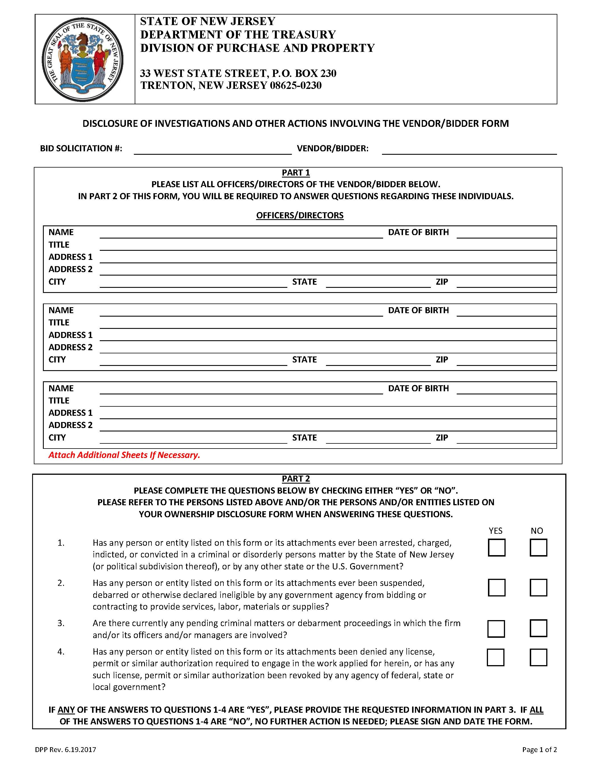

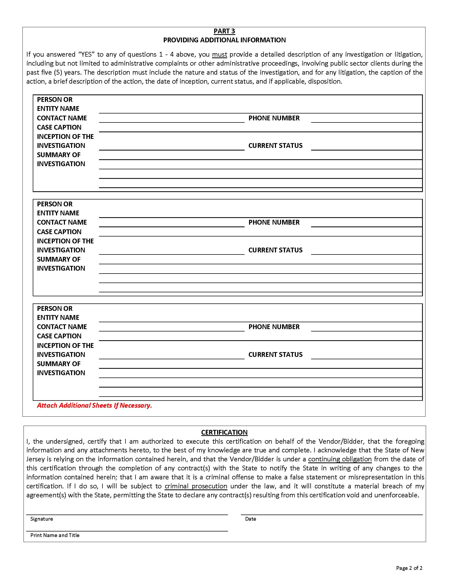

**TOWNSHIP OF MEDFORD**

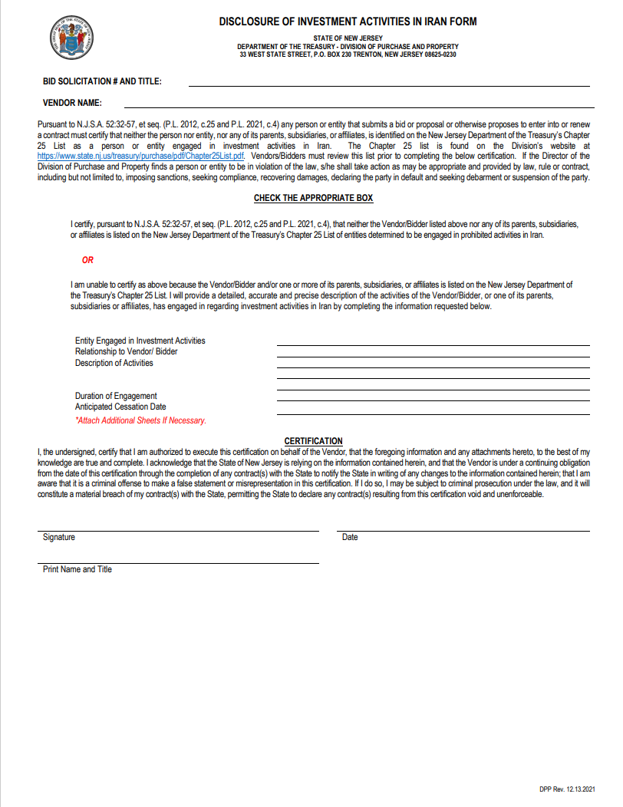

**TOWNSHIP OF MEDFORD**

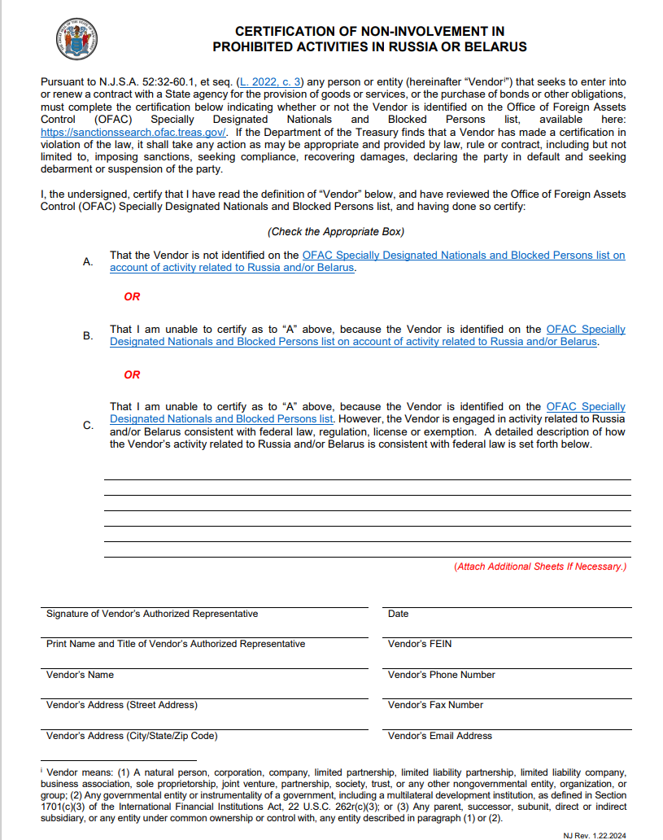

**X**

**TOWNSHIP OF MEDFORD**

**_________________________________________**

**CHECKLIST FOR BID SUBMITTAL**

**YES NO**

1.Bid Specifications _____ _____

2. Completed Bid Proposal Form _____ _____

3. Acknowledgment of Receipt of Addenda (if applicable) _____ _____

4. Ownership Disclosure Statement _____ _____

5. Non-Collusion Affidavit _____ _____

6. Affirmative Action Forms _____ _____

7. New Jersey Business Registration Certificate _____ _____

8. Disclosure of Investigations and Activities _____ _____

9. Disclosure of Investment Activities in Iran Form _____ _____­

10. Russia / Belarus Prohibited Activities Certification _____ _____

11. Tax Payer Identification Number and Certification _____ _____

(IRS form W-9)

12. Separate Sheet of Paper Demonstrating Equivalency _____ _____

(If applicable)