*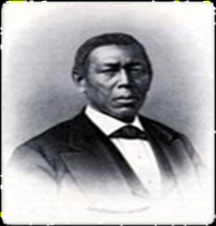****The Restoration and Development of***

***The Property of Dr. James Still***

**209 Church Road, Medford, New Jersey 08055**

The James Still Medical Office is located on the north side of Church Road, just east of the intersection of Church Road and North Main Street (Route 541) in Medford, New Jersey. Dr. Still’s residence, a three story Italianate house with a mansard roof, stood adjacent to the Office (to the east) until it was demolished in 1932. The significance of the Office is embodied in the accomplishments of James Still. An African American and the son of former slaves, James Still trained himself in the healing power of plants and herbs and succeeded in the practice of medicine in this form beginning about 1845, in spite of the challenges of social expectations, lack of education, poverty and pressure from traditional doctors who rejected herbalism as an unorthodox practice. He administered to patients of all backgrounds, achieved great respect throughout the region and through hard work and frugality amassed considerable wealth. He left an estate valued at the time at more than $20,000. The proposed period of significance for the site begins in 1839 when the land was purchased, and ends at the time of Still’s death in 1882.

**IF YOU WOULD LIKE TO SUPPORT THE RESTORATION OF THE DR. JAMES STILL MEDICAL OFFICE OR THE WORK OF THE DR. JAMES STILL EDUCATION CENTER, PLEASE SEND A DONATION TO: DR. JAMES STILL PROJECT, P.O. BOX 553, MEDFORD, NJ. Medford Historical Society is a registered 501{c} 3 and donations are considered “charitable” for tax purposes.**

 19th Century (1876) 20th Century

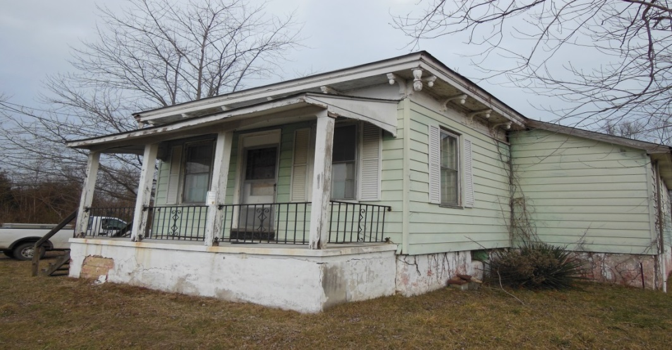

Current Appearance of the Property