### PREVENTION PLUS1PREVENTION PLUS1PREVENTION PLUS1PREVENTION PLUS1The Sobering Facts About Underage Drinking

**Provided by: Burlington County Coalition for Healthy Communities & Riverfront Coalition**

**www.prevplus.org**

* **Alcohol is the number one drug of choice for America’s youth.**  
  *(Source: Monitoring the Future, 2016)*
* **Alcohol kills more teens than all other illegal drugs *combined*.**

(Foundation for a drug free world 2016)

* **The number one place for obtaining alcohol by youth is their home. (2015-16 PRIDE Survey)**
* **Of the surveyed 12th grade students in Burlington County, 45.5% have used alcohol in the past 30 days** *(Source: 2015-16 NJ MS Pride survey)*
* **Approximately 395,000 underage youth in NJ drink each year.***(Source: 2016 Pacific Institute)*
* **The average age of first use of alcohol in Burlington County is 14.6 yrs old**  
  *(Source: (2015-16 PRIDE surveys)*
* **Studies show that children who begin drinking alcohol before the age of 15 are 5 to 7 times more likely than those who start after age 21 to develop alcohol problems.** *(Source: American Medical Association)*
* **Research indicates that the human brain continues to develop into a person’s early twenties and exposure of the developing brain to alcohol may have long-lasting effects on intellectual capabilities, may interrupt key processes of brain development and alcohol-induced brain damage may persist**.  *(Source: American Medical Association)*
* **14.6% of NJ youth had their first drink of alcohol, other than a few sips, before age 13.**  *(Source: Center for Disease Control, 2013, Youth Risk Behavior Surveillance System)*
* **The total cost of underage drinking in 2013 was $1.6 billion (problems include youth violence, traffic crashes, high-risk sex, property crime, injury, poisonings and psychoses, alcohol treatment, etc.).**  
  *(Source: Pacific Institute for Research and Evaluation 2013)*
* **23% of high school students reported that they binge drank in the past 30 days** (5 drinks for a male 4 for a female in one sitting**)** *(Source: P for Research and Evaluation 2016Pacific Institute)*
* **63% of 12th grade students reported drinking mostly on weekends. 54.5% said they use at a friends house. Source 2015-16 Pride Survey**
* **NJ Ranks 10th out of the 50 States in reported Underage Drinking resulting in $289 Million annual profit to Alcohol Industry.**

**(Source SAMSHA Office of Applied studies 2016 & Pacific Institute)**

#### Burlington County Coalition for Healthy Communities, a program of: Prevention Plus of Burlington County NJ, Inc., 5000 Sagemore Drive Suite 203 Marlton, NJ 08053 . 609-261-0001

***Joe Conlin, Coordinator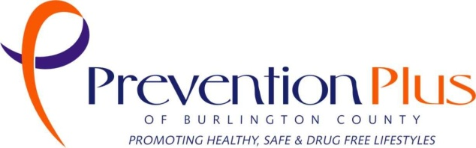 joeconlin@prevplus.org***